GeneTel DNA Gel Extraction and PCR Clean up Kit
A Kit for Fast Purification of DNA with High Yield

Introduction
This kit is designed for purification of DNA either from agarose gel or from PCR product of unique amplification. It yields high recovery of a broad size range of DNA fragments (see pictures below) that is highly pure, free from reactants contamination, and is good for a series of downstream manipulations such as cloning, sequencing, etc. The whole procedure takes only ~10-15 minutes for gel extraction, and less than 8 minutes for PCR clean up.
This kit is for research purpose only, not for diagnostic use.

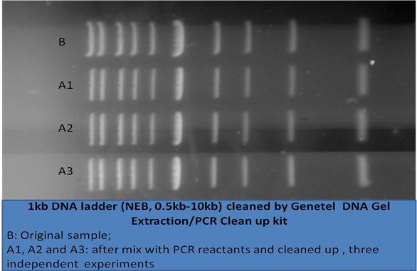

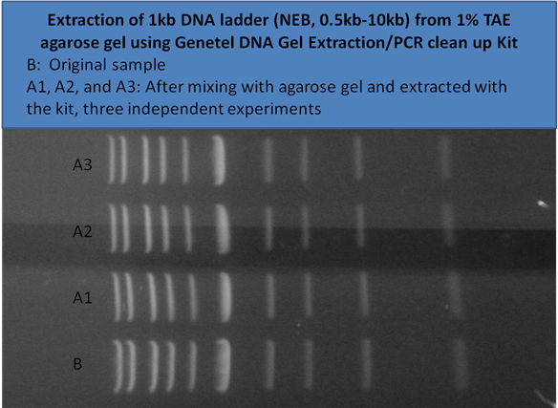

Kit Contents

Item | Applications
Item | 50 | 100 | 250
Binding column | 50 pcs | 100 pcs | 250 pcs
Collection tube | 50 pcs | 100 pcs | 250 pcs
GPS | 30 ml | 150 ml | 300 ml
GPC | 20 ml | 40 ml | 100 ml
GPW* | 7 ml | 14 ml | 35 ml
GPE | 5 ml | 10 ml | 20 ml
Manual | 1 copy | 1 copy | 1 copy

* Add ethanol before the first use as indicated on bottle label

Protocol
Remind!!!
Before the first time use of the kit, do add indicated volume of ethanol (supplied by user) to wash solution GPW and mix well.

DNA Extraction from agarose gel
- After gel electrophoresis, under UV illumination, cut out the gel piece (as small as possible) containing DNA band of interest, and place it into a clean tube of suitable volume.
- Weigh the gel piece and add 3 volumes of gel solubilizing solution GPS (300ul GPS to 100mg gel piece). Then incubate the tube at 55-60ºC until the gel completely dissolved (this usually takes 3-10 minutes depending on gel size and concentration; occasionally inverting the tube during incubation speeds up dissolving).
- Transfer the liquid of dissolved gel to the binding column seated in the collection tube, and spin at full speed (12,000-16,000g) for 30 seconds. Discard the flow-through, and replace the column into the collection tube. (if the volume is larger than one loading, finish the residual liquid by repeating this step, otherwise go to next step).
- Add 300ul cleaning solution GPC to the column and spin for 1 minute at full speed, discard the flow-through, and place the column back to the collection tube (avoid touch of the column bottom with the flow-through).
- Add 600ul wash solution GPW* to the column and spin for 30 seconds, discard the flow-through and place the column back into the collection tube. Give another 1 minute spin at full speed to get rid of any trace amount of washing solution. Then discard the collection tube. (* be sure that specified ethanol volume has been added to GPW before the first time use)
- Place the column into a clean 1.5ml microcuntrifuge tube, add 20-30ul eluting buffer GPE or water directly onto the membrane in column bottom, stand at room temperature for 2 minutes, then spin at full speed for 1 minutes to elute DNA from the column.

PCR clean up
- To the finished PCR reaction mixture, add water to adjust volume to 100ul, then add 300ul cleaning solution GPC.
- Transfer above solution into the binding column that has been placed in collection tube, and spin for 1 minute at full speed. Discard the flow through, place the column back into the collection tube.
- Add 600ul wash solution GPW* to the column and spin for 30 seconds, discard the flow-through and place the column back into the collection tube. Give another 1 minute spin at full speed to get rid of any trace amount of washing solution. Then discard the collection tube. (* be sure that specified ethanol volume has been added to GPW before the first time use).
- Place the column into a clean 1.5ml microcuntrifuge tube, add 20-30ul eluting buffer GPE or water directly onto the membrane in column bottom, stand at room temperature for 2 minutes, then spin at full speed for 1 minutes to elute DNA from the column

